2.14: (a) The displacement vector is:

The velocity vector is the time derivative of the displacement vector:

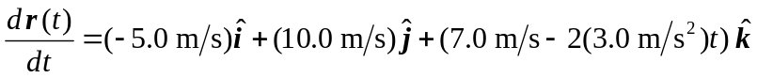

and the acceleration vector is the time derivative of the velocity vector:

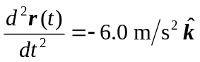

At t = 5.0 s:

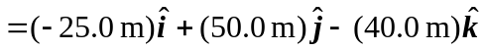
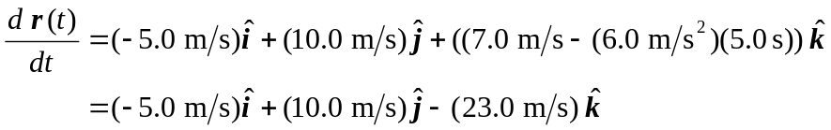
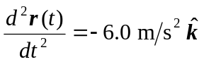

(b) The velocity in both the x- and the y-directions is constant and nonzero; thus the overall velocity can never be zero.
(c) The object's acceleration is constant, since t does not appear in the acceleration vector.

